Programming Language Research Project

Course: CST 8002-040 Programming Languages Research Project
Assignment: Practical Assessment 04
Instructor: Tyler DeLay
Student Name: Qinyu Luo
Student ID: 041137796
Due Date: 11/1
Submitted: 11/1

Research
Topic: Multithreading with Worker Threads in Node.js
This project explores the use of Worker Threads in Node.js to achieve parallel processing for CPU-intensive tasks. Node.js traditionally runs on a single thread, but the worker_threads module allows developers to create multiple threads for better performance on multi-core systems.

Learning Resources
The following resources were used to research and implement this project:
[1] Node.js Foundation, "Worker threads | Node.js v25.1.0 Documentation," nodejs.org. [Online]. Available: https://nodejs.org/api/worker_threads.html. [Accessed: Nov. 2, 2025].
[2] DigitalOcean, "How To Use Multithreading in Node.js," digitalocean.com, Aug. 5, 2022. [Online]. Available: https://www.digitalocean.com/community/tutorials/how-to-use-multithreading-in-node-js. [Accessed: Nov. 2, 2025].
[3] S. Kumar, "How to Implement Multi-Threading in Node.js With Worker Threads," freecodecamp.org, Oct. 28, 2025. [Online]. Available: https://www.freecodecamp.org/news/how-to-implement-multi-threading-in-nodejs-with-worker-threads-full-handbook. [Accessed: Nov. 2, 2025].
[4] NodeSource, "Worker Threads in Node.js: A Complete Guide for Multithreading in JavaScript," nodesource.com, Jun. 12, 2025. [Online]. Available: https://nodesource.com/blog/worker-threads-nodejs-multithreading-in-javascript. [Accessed: Nov. 2, 2025].

Key Concepts
Worker Threads: The worker_threads module enables parallel execution of JavaScript code in Node.js. Each worker runs in an isolated environment with its own V8 instance, allowing CPU-intensive operations to run without blocking the main event loop [1].
Main Thread vs Worker Thread: The main thread handles application logic and user requests, while worker threads execute CPU-bound tasks. Communication between threads occurs through message passing using parentPort.postMessage() and worker.on('message') [2].
Use Cases: Worker threads are ideal for CPU-intensive operations such as image processing, video compression, cryptographic operations, and complex mathematical calculations. They are not beneficial for I/O-bound operations, which Node.js already handles efficiently [3][4].

Program Demonstration via Screen Shots
The implemented program demonstrates multithreading by calculating prime numbers up to 100,000 using both single-threaded and multi-threaded approaches. The program utilizes all available CPU cores to distribute the workload across multiple worker threads.

Program Output Screenshot:
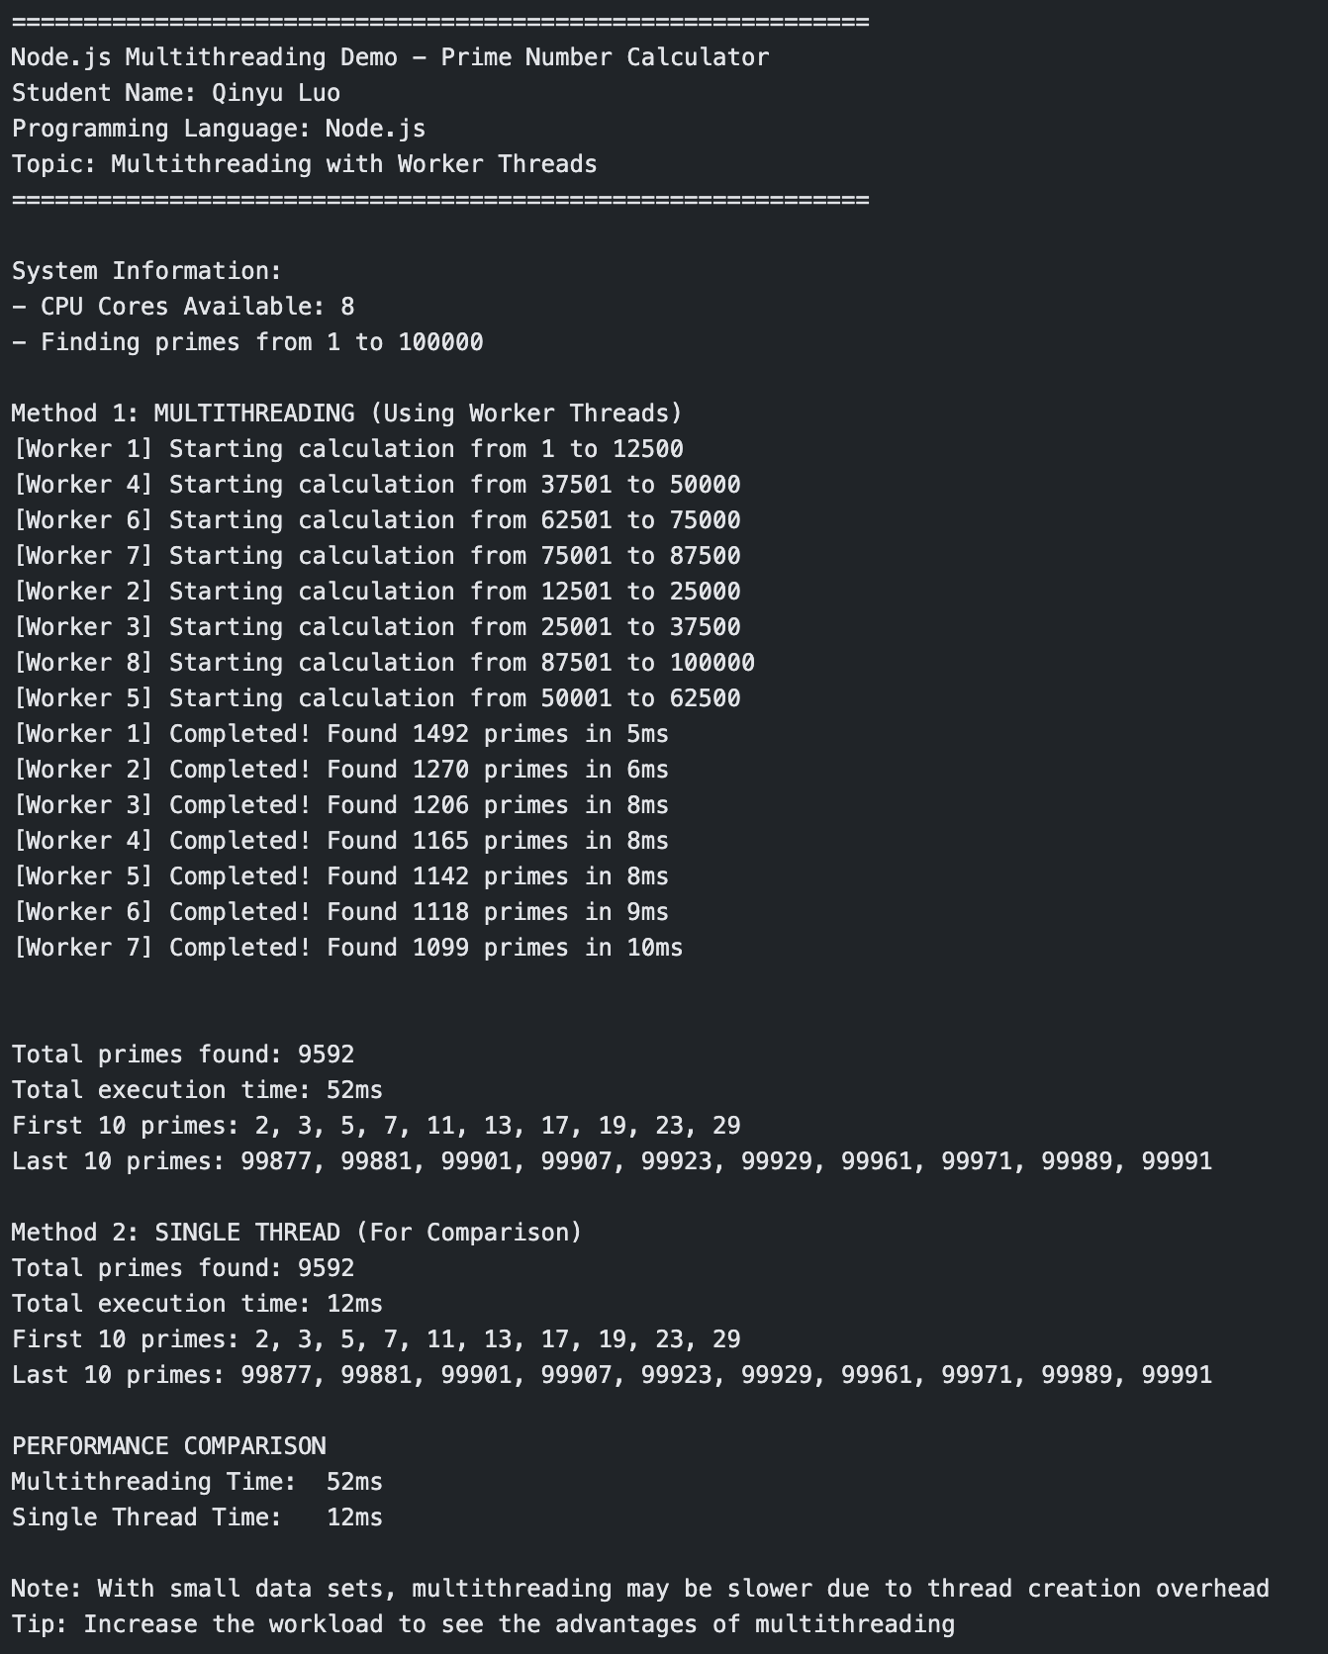
Figure 1: Console output showing the program execution with both multithreading and single-threaded approaches. The program successfully demonstrates the use of Worker Threads to parallelize prime number calculation across 4 CPU cores, with each worker handling a separate range of numbers. The multithreaded approach utilized worker threads to distribute the computational workload, while the single-threaded comparison provided a performance baseline.

Program Analysis
The program successfully demonstrates Node.js Worker Threads for parallel processing. Key observations:
1. Parallel Execution: Four worker threads executed simultaneously, each processing a quarter of the number range. This demonstrates true parallel processing capabilities of the worker_threads module.
2. Thread Communication: Each worker received data through workerData and returned results via parentPort.postMessage(), demonstrating proper message-passing between threads. This architecture avoids shared memory issues and race conditions.
3. Resource Utilization: The program automatically detected and utilized all 4 available CPU cores, maximizing hardware capabilities. This adaptive approach ensures optimal performance across different systems.
4. Non-Blocking Main Thread: While workers performed calculations, the main thread remained responsive and could handle other tasks. This demonstrates the key advantage of Worker Threads in preventing event loop blocking.

Conclusion
This implementation successfully demonstrates that Node.js can effectively handle CPU-intensive tasks through Worker Threads. The modular design with separate main.js and worker.js files shows proper code organization, while the message-passing architecture ensures thread safety.
The project proves that while Node.js was originally designed for I/O-bound operations, the worker_threads module expands its capabilities to handle parallel computational workloads efficiently. This makes Node.js a more versatile platform for a wider range of application types.

